
Ensuring environmental protection & conserving biodiversity

FOLLOW-UP INVESTIGATIVE ASSESSMENT REPORT ON THE ARCELORMITTAL LIBERIA (AML) BOLO TOWN POLLUTION INCIDENT, GBA CLAN, GBEH CHIEFDOM, YARMEIN ADMINISTRATIVE DISTRICT, NIMBA COUNTY
Environmental Assessment of Pollution-Affected Water Bodies, Farmlands, Community Livelihoods, and Regulatory Compliance

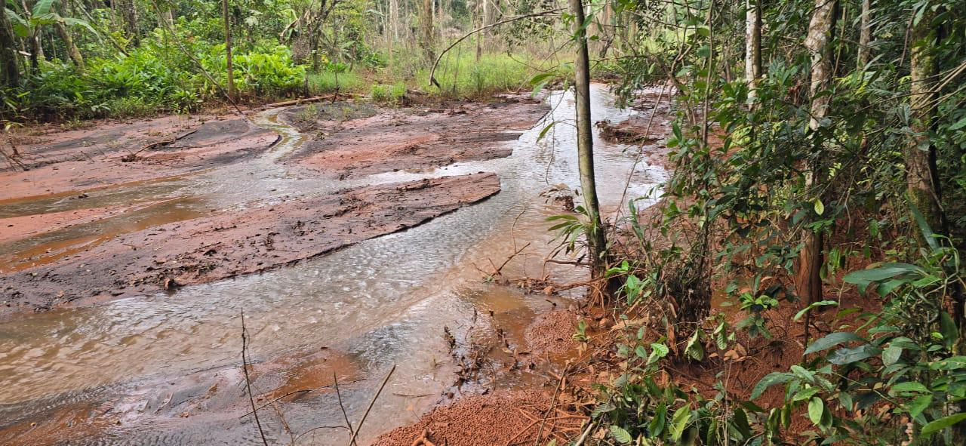

AN ASSESSMENT REPORT PREPARED BY A TECHNICAL TEAM OF THE ENVIRONMENTAL PROTECTION AGENCY (EPA), LIBERIA

Date of Investigative Assessment: October 13, 2026
WORKING DRAFT – sections marked [To be added] are pending inputs

Table of Contents
Executive Summary
Introduction
Background and Context
Methodology
Investigative Team Structure
Opening Conference with ArcelorMittal Liberia
Issue of Obsolete Nitrate Acid
Community Engagement at Bolo Town
Initial Environmental Pollution Findings
Assessment of the Extent of the Affected Areas
Access to Farms and the Damaged-Farm Survey
Community Concerns Regarding Crop Compensation
Alleged Failure to Heed Earlier Community Warnings
AML’s Geofencing Exercise and the Community’s Response
Community Position on Further Decisions
AML’s Request for the Investigative Report
Increasing Tensions during the Consultation
Site Inspection and Physical Observations
Yeewa, Yeewa Korweny 1 and 2 (ES Group)
Pompleh and Wehyee Streams (VA Group)
Wenee, Saymenee, Alphonso Farm and Neneyee (JC Group)
Laboratory Analysis and Quality Assurance/Quality Control (QA/QC)
Water Quality Sampling and Analysis
Sampling Locations and Rationale
Analytical Results
Preliminary Interpretation of Results
Environmental and Public Health Impact Assessment
Preliminary Conclusions
Conclusion and Recommendations
Overall Conclusion
Recommendations
Appendices
Appendix A: Photos from the Investigation
Appendix B: Source Documents
Page numbers: right-click the list above and choose “Update Field” (or press F9).

LIST OF ABBREVIATIONS
Abbreviation | Meaning
AF | Alphonso Farm (sample code prefix)
AML | ArcelorMittal Liberia Limited
DS / MS / US | Downstream / Mid-stream / Upstream (sampling station)
EPA | Environmental Protection Agency of Liberia
ES | Emmanuel Suah group (Group 1 – Yeewa, Yeewa Korweny 1 & 2); sample code suffix
GPS | Global Positioning System
JC | Joseph Charles group (Group 3 – Wenee, Saymenee, Alphonso farm, Neneyee); sample code suffix
LRA | Liberia Revenue Authority
LWQS | Liberian Water Quality Standards
mg/L | Milligrams per litre
NEN | Neneyee (sample code prefix)
POM | Pompleh (sample code prefix)
QA/QC | Quality Assurance / Quality Control
RAP | Resettlement Action Plan
SM | Saymenee (sample code prefix)
SW | Surface Water (sample matrix)
TDS | Total Dissolved Solids
TSS | Total Suspended Solids
VA | Varney Armah group (Group 2 – Wehyee and Pompleh); sample code suffix
W | Wehyee (sample code prefix)
WE | Wenee (sample code prefix)
YEEWA | Yeewa main stream (sample code prefix)
YWK1 | Yeewa Korweny 1 – Dor tributary (sample code prefix)
YWK2 | Yeewa Korweny 2 – Patel tributary (sample code prefix)

EXECUTIVE SUMMARY
Following the preliminary investigation of August 13, 2026 into the complaint lodged by the leadership of Bolo Town, Gba Clan, Gbeh Chiefdom, Yarmein Administrative District, Nimba County, the Environmental Protection Agency of Liberia (EPA) undertook a follow-up investigative assessment on October 13, 2026. The initial investigation had established that iron-rich, sediment-laden discharges from ArcelorMittal Liberia (AML) operations at Mount Yeleweliton (Yuelliton) and Mount Gangra were entering local water resources and farmlands through six identified discharge points, and had identified regulatory compliance concerns which resulted in a total enforcement obligation of US$500,000 being imposed on AML.
The October 13 assessment was intended to deepen the investigation by examining the pollution-affected water bodies and discharge pathways, collecting additional environmental samples, determining the extent of the affected area including agricultural land, engaging Bolo Town leadership and residents, and clarifying the disagreements surrounding AML’s geofencing exercise and farm-damage survey. The EPA team was organised into three environmental sampling and field assessment groups and one Social Team.
Field observations by the sampling groups recorded visibly turbid, brownish to reddish-brown water with suspended sediment in all streams inspected, substantial iron-ore sediment deposits in the Yeewa main stream and its Yeewa Korweny tributaries draining the Mount Yeleweliton area, an agricultural farm inundated by sediment originating from the mining area, and an AML geo-fencing sign (“KEEP AWAY – 500 Meters Safety Buffer Zone”) at Yeewa Korweny 2. Preliminary Total Suspended Solids (TSS) results show gross exceedance of the Liberian Water Quality Standard (Class III, ≤50 mg/L) throughout the Yeewa system (up to 2,400 mg/L at YWK2-ES-SW-002) and at the Alphonso farm (1,067 mg/L), moderate exceedance in the Wenee and Saymenee streams, and compliant values in the Wehyee and Pompleh streams except at POM-SW-VA-003.
The community consultation did not resolve the outstanding social issues. The geographical extent of the affected area remains disputed, the damaged-farm survey remains unresolved, and crop compensation is a major source of disagreement. The EPA Team Lead directed AML to suspend its RAP-related or damaged-farm survey activities pending further regulatory direction, and a follow-up EPA visit is to address the RAP process and enforcement of the Corrective Action Plans.
[To be added: To be completed once the full laboratory results (heavy metals, physico-chemical parameters) and the final recommendations are available.]

INTRODUCTION

BACKGROUND AND CONTEXT
Origin of the Complaint
The EPA received complaints concerning environmental pollution affecting water resources and farmlands in Bolo Town, Nimba County. The complaints prompted an EPA investigation into the reported impacts associated with mining-related discharges from AML’s operations.
According to the initial investigative findings, iron-rich and sediment-laden discharges were entering local water resources and farmlands through six identified discharge points. These observations raised concerns about water quality, sediment deposition, agricultural productivity, and the potential disruption of community livelihoods.
The initial investigation also identified regulatory compliance concerns involving:
- Failure to report pollution incidents in accordance with applicable environmental permit conditions.
- Failure to submit the mandatory Q2 2026 Environmental Monitoring Report.
- Failure to meet the EPA’s final compliance deadline of August 25, 2026.
The October 13, 2026 assessment was undertaken to deepen the investigation, collect additional environmental evidence, engage affected residents, and determine the next steps required to address the reported pollution and its consequences.
Enforcement Measures Previously Imposed
Following the initial investigation and the identified regulatory concerns, a total enforcement obligation of US$500,000 was imposed on AML, structured as follows:
Table 1: Enforcement measures imposed on AML following the initial investigation
Enforcement measure | Amount (US$) | Direction
A. Administrative Fine | 400,000 | To be paid into the Government of Liberia Consolidated Account through the Liberia Revenue Authority (LRA) within ten working days.
B. Technical and Environmental Research Payment | 100,000
 | 500,000

Purpose of the October 13 Assessment
The assessment was intended to advance the EPA’s investigation by:
- Examining pollution-affected water bodies, discharge pathways, and surrounding environmental receptors.
- Collecting environmental samples for further analysis.
- Determining the extent of potentially affected areas, including agricultural lands.
- Engaging Bolo Town leadership and residents on environmental damage and livelihood impacts.
- Clarifying the disagreements surrounding AML’s geofencing and farm-damage survey.
- Identifying outstanding issues requiring corrective action, regulatory intervention, or further consultation.

METHODOLOGY
The follow-up assessment was conducted using the following methodology:
- Review of the initial investigation report, the enforcement measures imposed, and the correspondence between the EPA, AML and the Bolo Town leadership.
- Opening conference with AML representatives to explain the EPA’s Terms of Reference, the scope of the exercise and the respective roles of the EPA team and AML.
- Deployment of three environmental sampling and field assessment groups to the pollution-affected water bodies, with photographic and GPS documentation of field observations.
- Collection of surface water samples from the identified water bodies for laboratory analysis under EPA Chain-of-Custody protocols (analysis commenced October 15, 2026).
- Community consultation by the Social Team with Bolo Town leadership and residents on farm damage, access, compensation and the farm-damage survey process.
- Closing of the consultation and identification of outstanding issues for the subsequent EPA visit.

INVESTIGATIVE TEAM STRUCTURE
The EPA team, led by Director Rafael S. Ngumbu, was divided into four groups to facilitate the technical and social components of the assessment: three environmental sampling and field assessment groups headed by Emmanuel Suah (ES), Varney Armah (VA) and Joseph Charles (JC), and a Social Team headed by Mr. Ngumbu.
Table 2: Composition and assignments of the EPA investigative team
Team | Lead / designation | Assignment
Group 1 (ES) | Emmanuel Suah | Environmental sampling and field assessment – Yeewa main stream, Yeewa Korweny 1 (Dor) and Yeewa Korweny 2 (Patel).
Group 2 (VA) | Varney Armah | Environmental sampling and field assessment – Wehyee and Pompleh streams.
 | Joseph Charles | Environmental sampling and field assessment – Wenee, Saymenee, Alphonso farm and Neneyee (northern sediment control station).
Group 4 (Social Team) | Rafael S. Ngumbu (EPA Team Lead) | Engagement of Bolo Town leadership and residents on farm damage, access, compensation and the farm-damage survey process.

Environmental Sampling and Field Assessment Teams
Three groups were assigned to:
- Collect environmental samples from the identified pollution-affected areas.
- Examine affected water bodies and surrounding areas.
- Assess the geographical extent of the reported environmental impacts.
- Identify locations requiring additional investigation.
- Document field observations relevant to the pollution complaint.
The sampling exercise was intended to generate further evidence for determining the nature and distribution of contamination.
Social Assessment Team
The fourth group, designated as the Social Team, was assigned to engage Bolo Town leadership and residents. Its responsibilities included discussing:
- The reported destruction or damage of farms and crops.
- Access to affected farms and agricultural properties.
- The process for identifying affected farmers and households.
- Crop compensation and other potential livelihood-related losses.
- Community concerns about AML’s farm-damage survey.
- The need for an acceptable process for resolving outstanding social issues.
The consultation was intended to provide the EPA with a clearer understanding of the community’s concerns and the obstacles affecting the resolution of the incident.

OPENING CONFERENCE WITH ARCELORMITTAL LIBERIA
An opening conference was held at the commencement of the October 13 assessment. The purpose was to explain the EPA’s Terms of Reference, outline the scope of the investigative exercise, and clarify the respective roles of the EPA team and AML representatives.
During the conference, the EPA acknowledged AML for meeting its licensing obligation. AML, in turn, expressed appreciation to the EPA for its engagement and participation in the assessment. AML also requested that the EPA share the investigative report upon completion of the exercise.

ISSUE OF OBSOLETE NITRATE ACID
The issue of obsolete nitrate acid was raised during the opening conference. In response, the EPA Team Lead, Director Rafael Ngumbu, explained the Agency’s applicable disposal protocols. The issue was noted as a separate environmental management and chemical-handling concern requiring appropriate documentation and follow-up.
[To be added: List of AML and EPA participants at the opening conference (names and positions), as in the initial report.]

COMMUNITY ENGAGEMENT AT BOLO TOWN

INITIAL ENVIRONMENTAL POLLUTION FINDINGS
The initial EPA investigation identified iron-rich, sediment-laden discharges entering local water resources and farmlands through six distinct discharge points.
During the October 13 community consultation, Mr. Rafael Ngumbu reiterated that the initial assessment had found pollution in the affected water bodies. He explained that observed turbidity could be associated with suspended sediments and potentially with chemical constituents requiring further analysis.
The EPA’s preliminary observations were communicated to both AML representatives and Bolo Town leadership before the October 13 investigative assessment commenced. The initial report was also shared with the relevant representatives of AML and the community leadership to inform the engagement and provide a basis for the subsequent assessment.

ASSESSMENT OF THE EXTENT OF THE AFFECTED AREAS
One of the principal objectives of the October 13 assessment was to determine the extent of the pollution-affected areas, including water resources, farmlands, and other potentially affected community assets. The three environmental teams were assigned to undertake sampling and field observations for this purpose.
However, the consultation revealed that the geographical extent of the affected area remained disputed. AML indicated that it had conducted its own geofencing exercise before the EPA’s arrival to identify the extent of the pollution. Bolo Town residents rejected AML’s assessment as an adequate representation of the actual impact. Community representatives maintained that more farms, agricultural properties, and individuals had been affected than were included within the boundaries identified by AML.
The disagreement indicates that the boundaries established through AML’s geofencing exercise had not been accepted by the community as a conclusive determination of the affected area. The EPA must therefore independently evaluate the relevant geographical information and field evidence before determining the final extent of the impact.

ACCESS TO FARMS AND THE DAMAGED-FARM SURVEY
Access to affected farms emerged as a significant concern during the assessment. The engagement revealed that disputes concerning access to farms, disagreements over crop compensation, and AML’s alleged failure to adequately heed earlier warnings and advice from Bolo Town contributed to the deterioration of relations between the company and the community. These concerns were raised in the context of the ongoing effort to identify and quantify damaged farms.
A senior elder representing the Town Chief, who was reported to be ill, stated that the community had stopped AML from conducting its proposed farm survey. According to the representative, the approach adopted by AML was not considered a normal or appropriate process for determining the extent of agricultural damage.
Community residents also deliberately declined to agree to the survey at that stage, explaining that many farm owners were not present in Bolo Town. They stated that a significant number of the affected owners were in Monrovia and were preparing to return. The community’s position was that a credible survey should not proceed without adequate participation by the relevant farm owners and an agreed process for determining the losses sustained. These issues remain unresolved.

COMMUNITY CONCERNS REGARDING CROP COMPENSATION
Crop compensation emerged as a central issue during the consultation. The discussion indicated that residents were concerned not only about the identification of polluted areas but also about the number of farms and crops affected, the valuation of losses, and the adequacy of the compensation process.
The disagreement over AML’s geofencing exercise has contributed to uncertainty about which farm owners and residents should be included in any assessment of agricultural damage. Community representatives maintained that persons and farms located outside AML’s identified boundaries may also have sustained losses. Consequently, the number of affected farms, the number of eligible owners, the quantity and type of damaged crops, and the total value of agricultural losses have not been conclusively established.

ALLEGED FAILURE TO HEED EARLIER COMMUNITY WARNINGS
During the consultation, concerns were raised that AML had not adequately adhered to warnings and advice previously provided by Bolo Town residents regarding the activities or conditions that contributed to the incident. Community representatives associated these concerns with the damage to farms, difficulties relating to access, and the subsequent dispute over compensation.

AML’S GEOFENCING EXERCISE AND THE COMMUNITY’S RESPONSE
AML stated during the community consultation that it had independently undertaken a geofencing exercise before the EPA’s arrival to determine the extent of the pollution. Community representatives disputed the adequacy of that exercise on two principal grounds:
- They believed that the assessment excluded additional affected farms and individuals.
- They questioned the appropriateness of AML determining the boundaries of the affected area without independent regulatory oversight.
The disagreement reflects a lack of consensus over the geographical scope of the incident and the evidence to be used in identifying affected properties.

COMMUNITY POSITION ON FURTHER DECISIONS
The senior elder representing the Town Chief stated that Bolo Town cannot make any further or final decision until the community’s lawyers review the EPA’s initial reports. The representative further indicated that the reports would be discussed with other elders and that the community intends to conduct or ascertain its own survey to determine the extent of damaged farms and crops. According to the representative, the community would determine the appropriate way forward after these consultations and assessments had been completed.

AML’S REQUEST FOR THE INVESTIGATIVE REPORT
AML requested that the EPA provide the investigative report at the conclusion of the assessment.

INCREASING TENSIONS DURING THE CONSULTATION
As discussions progressed, tensions increased over the geographical boundaries of the affected area, the farm-damage survey, the identification of affected persons, and crop compensation. The community maintained that AML’s geofencing exercise did not capture the full extent of the damage. AML, meanwhile, had indicated that it had already assessed the affected area. The unresolved differences made it difficult to reach a common understanding of the farm-survey process and the steps required to establish agricultural losses.
In response, Mr. Ngumbu instructed AML to stop its RAP-related or damaged-farm survey activities pending further regulatory direction. He emphasised the need to allow the appropriate regulators to perform their functions. He further requested that the consultation be closed and that the outstanding issues be addressed during a subsequent EPA visit expected within the following days. The planned follow-up is intended to address the RAP process and enforcement of the EPA’s Corrective Action Plans.
The consultation was subsequently closed without a final community agreement on the extent of damaged farms, compensation, or the broader resolution of the incident.

SITE INSPECTION AND PHYSICAL OBSERVATIONS
The sampling groups inspected the affected water bodies while collecting samples. Physical observations were documented photographically and by GPS coordinates. The following preliminary observations were recorded by each group.

YEEWA, YEEWA KORWENY 1 AND 2 (ES GROUP)
The ES group inspected the Yeewa main stream and its two tributaries, Yeewa Korweny 1 (Dor) and Yeewa Korweny 2 (Patel):
- An agricultural farm was observed to have been inundated and covered by sediments originating from the mining area. This may affect the overall productivity of the farmland.
- The presence of iron ore sediment was observed along the waterway during the sampling.
- The turbidity levels at Yeewa and Yeewa Korweny 2 were higher than those at Yeewa Korweny 1.
- A geo-fencing sign was observed at Yeewa Korweny 2 bearing the inscription: “KEEP AWAY – 500 Meters Safety Buffer Zone”.
- All the sampling points were located within natural water bodies.
- Yeewa Korweny 1 and Yeewa Korweny 2 are tributary branches of the Yeewa main stream, situated on opposite sides of the main watercourse. Both originate in the Mount Yewlliton area and flow through deep valleys characterised by dense forest cover. The tributaries were also observed to contain substantial sediment deposits. Their locations are in proximity to ArcelorMittal’s haulage route and to mining activities in the Mount Yewlliton and Mount Gangro areas. The proximity of mining and haulage activities, together with the observed sedimentation, warrants further investigation into possible sediment transport pathways. Nevertheless, the field observations alone do not establish that ArcelorMittal’s activities caused the sedimentation or any chemical pollution.

POMPLEH AND WEHYEE STREAMS (VA GROUP)
During the field visit, the VA team conducted surface water sampling along the Wehyee and Pompleh streams. The following observations were recorded (see Appendix A, Plates 1–4):
- The stream water was brownish to reddish-brown and visibly turbid, with suspended particles and sediment apparent in the flowing water.
- Both streams flow through a densely vegetated environment characterised by abundant trees, shrubs, ferns and other ground vegetation.
- The streambanks were uneven, with exposed soil, roots and areas of erosion visible along the channel.
- The presence of suspended sediment and the water’s discoloration may indicate soil erosion and sediment runoff into the stream, potentially influenced by rainfall and surface-water movement. However, the specific cause of the discoloration cannot be confirmed through visual observation alone.
- The surrounding vegetation provides natural streambank cover, although localised exposed soils and disturbed bank sections may contribute to sediment entering the water.
- Around the collection points along the Pompleh and Wehyee streams, there were no visible signs of possible environmental pollution due to mine runoff on the nearby farmlands.
- Water samples were collected for subsequent analysis to assess the streams’ water quality and determine whether their physical and chemical characteristics meet the applicable environmental standards.

WENEE, SAYMENEE, ALPHONSO FARM AND NENEYEE (JC GROUP)
Photographs taken by the JC group during sampling show reddish-brown, visibly turbid water with iron-rich sediment blanketing the stream beds and banks, and low-lying land inundated by sediment-laden water (see Appendix A, Plates 5–8).
[To be added: Written physical observations of the JC group at the Wenee, Saymenee, Alphonso farm and Neneyee sampling points.]

LABORATORY ANALYSIS AND QUALITY ASSURANCE/QUALITY CONTROL (QA/QC)
Laboratory analysis of the surface water samples commenced on October 15, 2026. The parameters are those associated with iron ore exploitation and sediment transport, consistent with the initial investigation.
- Analytical parameters reported to date: Total Suspended Solids (TSS), measured by colorimeter and compared against the Liberian Water Quality Standard (LWQS) Class III limit of ≤50 mg/L.
- Quality assurance / quality control: samples were collected in pre-treated laboratory bottles under Chain-of-Custody and analysed ex-situ; each test is conducted in triplicate and reported as a cumulative mean, consistent with the initial investigation.
[To be added: Remaining analytical parameters and methods (pH, conductivity, turbidity, TDS, nutrients, iron and other heavy metals) and the applicable LWQS class for each, as in Table 3 of the initial report.]

WATER QUALITY SAMPLING AND ANALYSIS

SAMPLING LOCATIONS AND RATIONALE
Surface water sampling on October 13, 2026 extended the network of the initial investigation to the tributaries and creeks reported by the community, with each stream sampled at downstream, mid-point and upstream stations so that spatial sediment migration could be evaluated along the flow path:
- Yeewa system (ES group): the Yeewa main stream (YEEWA-DS/MS/US) and its two tributaries Yeewa Korweny 2 – Patel (YWK2-ES-SW-001 to 003) and Yeewa Korweny 1 – Dor (YWK1-ES-SW-001 to 003), which originate in the Mount Yeleweliton area and lie in proximity to AML’s haulage route and the Mount Yeleweliton and Mount Gangra mining areas.
- Wehyee and Pompleh streams (VA group): W-SW-VA-001 to 003 and POM-SW-VA-001 to 003, flowing through densely vegetated terrain north-east of Bolo Town.
- Wenee, Saymenee, Alphonso farm and Neneyee (JC group): the Wenee stream (WE-JC-SW-001, 002 and WE-SW-JC-003 at the confluence with Saymenee), Saymenee mid-point (SM-SW-JC-001), the inundated Alphonso farm (AF-SW-JC-001) and Neneyee upstream (NEN-SW-JC-001), designated the northern sediment control station.
Sample identification, GPS coordinates, sampling time and the field description of each sampling point are presented in Table 3. Descriptions for the ES and VA group points (shaded) are derived from the groups’ field notes; descriptions for the JC group points are pending.
Table 3: Surface water quality sample information, Bolo Town, Nimba County (Date of assessment: October 13, 2026; sample matrix: water; analysis start date: October 15, 2026)
Sample Location | Sample ID | GPS Coordinates |  | Sampling Time | Description
Sample Location | Sample ID | Latitude | Longitude | Sampling Time | Description
Wenee Downstream | WE-JC-SW-001 | 0542501 | 0834879 | 2:08 PM
Wenee mid-point | WE-JC-SW-002 | 0542460 | 0834664 | 2:21 PM | —
Wenee Upstream (confluence with Saymenee) | WE-SW-JC-003 | 0542353 |  | 2:36 PM | —
Saymenee mid-point |  | 0542304 |  | 2:45 PM | —
Alphonso farm | AF-SW-JC-001 | 7.547899 | -8.616177 |  | —
 | NEN-SW-JC-001 | 7.537928 | -8.614119 | 4:24 PM | —
Wehyee Downstream | W-SW-VA-001 |  | -8.60949 | 2:58 PM | Downstream surface water sample collected along the Wehyee stream within a densely vegetated channel. Water was brownish to reddish-brown and visibly turbid, with suspended particles and sediment apparent in the flowing water. No visible sign of mine-runoff pollution was observed on the nearby farmland.
Wehyee Mid-point |  | 7.56695 |  |  | Mid-point surface water sample collected along the Wehyee stream to assess spatial variation in sediment load. The stream was turbid and reddish-brown, with uneven banks showing exposed soil, roots and localised erosion along the channel.
Wehyee Upstream | W-SW-VA-003 | 7.56724
 | POM-SW-VA-001 | 7.56793 |  | 3:03 PM | Downstream surface water sample collected along the Pompleh stream within dense vegetation. Brownish, visibly turbid water with suspended sediment was observed; no visible sign of mine-runoff pollution was noted on the adjacent farmland.
Pompleh Mid-point | POM-SW-VA-002 | 7.56822 | -8.60947 |  | Mid-point surface water sample collected along the Pompleh stream. The channel was turbid and reddish-brown, flowing through abundant ground vegetation with uneven, partially eroded streambanks.
 | POM-SW-VA-003 |  |  |  | Surface water sample collected further along the Pompleh stream to evaluate the combined sediment load. Water was discoloured and turbid, with suspended particles consistent with soil erosion and sediment runoff into the stream.
 | YEEWA-DS | 542444 | 834881 | 2:09 PM | Downstream surface water sample collected from the Yeewa main stream, a natural water body, below the inflow of the Yeewa Korweny 1 and 2 tributaries. Iron ore sediment was observed along the waterway and turbidity was visibly higher than at Yeewa Korweny 1.
 |  | 542314 | 834915 | 2:16 PM
 |  | 542066 |  | 2:32 PM
 | YWK2-ES-SW-001 | 0541616 | 0835024 | 3:15 PM | Downstream surface water sample collected from Yeewa Korweny 2 (Patel), a tributary of the Yeewa main stream, just above its junction with the main watercourse. Substantial sediment deposits were observed and turbidity was higher than at Yeewa Korweny 1.
 | YWK2-ES-SW-002 |  |  |  | Midstream surface water sample collected along Yeewa Korweny 2 (Patel) within a deep, densely forested valley. A geo-fencing sign reading “KEEP AWAY – 500 Meters Safety Buffer Zone” was observed on this tributary, in proximity to ArcelorMittal’s haulage route.
 | YWK2-ES-SW-003 |  | 0834786 | 3:21 PM
 | YWK1-ES-SW-001
 |  | 0541644 | 0835167
Yeewa korweny Dor Midstream |  | 0541607 | 0835271 | 3:59 PM | Upper surface water sample collected on Yeewa Korweny 1 (Dor) towards its source in the Mount Yewlliton area, located in proximity to ArcelorMittal’s haulage route and the Mount Yewlliton / Mount Gangro mining areas. Natural water body with sediment deposits in the channel.

ANALYTICAL RESULTS
The Total Suspended Solids results for the twenty-one surface water samples are presented in Table 4 against the LWQS Class III limit.
Table 4: Surface water quality result – Total Suspended Solids (TSS)
Sample Code | Sample Parameter | LWQS Class III | Instrumentation
Sample Code | Total Suspended Solid (TSS) (mg/L) | LWQS Class III | Instrumentation
YEEWA-DS | 532
YEEWA-MS | 523
YEEWA-US | 628
YWK2-ES-SW-001
YWK2-ES-SW-002 | 2,400
YWK2-ES-SW-003 | 769
 | 259
W-SW-VA-001
POM-SW-VA-002 | 24
WE-JC-SW-001
 | 214
NEN-SW-JC-001

[To be added: Tables 5a/5b – results of the remaining physico-chemical and heavy-metal analyses, as in Tables 4a and 4b of the initial report.]

PRELIMINARY INTERPRETATION OF RESULTS
The TSS results confirm the field observations of heavy sediment loading in the water bodies draining the Mount Yeleweliton area. The results are summarised by stream in Table 5.
Table 5: Summary of TSS results by stream relative to the LWQS Class III limit (≤50 mg/L)
Stream / system | Sample codes | TSS range (mg/L)
Yeewa main stream (ES) | YEEWA-DS / MS / US | 523 – 628 | All exceed (≈10–13×)
Yeewa Korweny 2 – Patel (ES) | YWK2-ES-SW-001 – 003 | 769 – 2,400 | All exceed (≈15–48×); highest of the survey
Yeewa Korweny 1 – Dor (ES) | YWK1-ES-SW-001 – 003 | 188 – 259 | All exceed (≈4–5×)
Wehyee (VA) | W-SW-VA-001 – 003 | 20 – 24 | All within standard
Pompleh (VA) | POM-SW-VA-001 – 003 | 11 – 164 | 001 and 002 within standard; 003 exceeds (≈3×)
Wenee (JC) | WE-JC-SW-001 / 002, WE-SW-JC-003 | 102 – 214 | All exceed (≈2–4×)
Saymenee (JC) | SM-SW-JC-001 | 84 | Exceeds (≈1.7×)
Alphonso farm (JC) | AF-SW-JC-001 | 1,067 | Exceeds (≈21×)
Neneyee upstream control (JC) | NEN-SW-JC-001 | 92 | Exceeds (≈1.8×)

- Yeewa system: every sample exceeded the standard by an order of magnitude or more. The highest values of the survey were recorded on Yeewa Korweny 2 (Patel), reaching 2,400 mg/L at the midstream station (YWK2-ES-SW-002), consistent with the field observation that turbidity on Yeewa and Yeewa Korweny 2 was visibly higher than on Yeewa Korweny 1 (188–259 mg/L). The upstream Yeewa station (628 mg/L) was not cleaner than the downstream stations, indicating that the sediment load originates further up the Yeewa catchment.
- Alphonso farm: the sample taken at the inundated farm (1,067 mg/L) corroborates the observation of sediment deposition on agricultural land.
- Wenee and Saymenee: moderate exceedances (84–214 mg/L), with the highest value at the Wenee–Saymenee confluence.
- Wehyee and Pompleh: values were within the standard (11–24 mg/L) at five of six stations despite the brownish, turbid appearance recorded in the field; the exception was POM-SW-VA-003 (164 mg/L). The VA group observed no visible sign of mine-runoff pollution on the adjacent farmland, and attributed the discoloration possibly to local bank erosion and rainfall runoff.
- Control station: the Neneyee northern sediment control station returned 92 mg/L, above the Class III limit. Its suitability as an unaffected baseline should be reviewed once the full analytical suite is available.
These interpretations are preliminary and limited to a single physical parameter. As noted by the field teams, the observations alone do not establish the source of the sediment or any chemical pollution; the complete laboratory results are required to characterise the contamination and its pathways.

ENVIRONMENTAL AND PUBLIC HEALTH IMPACT ASSESSMENT
[To be added: Assessment of ecological, agricultural and public health impacts, to be prepared once the complete laboratory results and the farm-damage extent are available.]

PRELIMINARY CONCLUSIONS
Based on the engagement from the October 13, 2026 assessment, the following preliminary conclusions are drawn.
- Environmental concerns were identified during the initial investigation. The initial EPA findings identified iron-rich, sediment-laden discharges entering local water resources and farmlands through six distinct discharge points. Further laboratory and field evidence was required to establish the full extent and characteristics of the environmental impacts.
- The geographical extent of the affected area remains disputed. AML’s geofencing exercise has not been accepted by Bolo Town residents as a complete representation of the affected area. Independent EPA verification is required to establish the boundaries and identify potentially omitted farms and affected persons.
- The damaged-farm survey remains unresolved. Community representatives objected to AML’s proposed survey process and cited the absence of many farm owners from the town. The survey process requires further coordination and regulatory direction.
- Crop compensation is a major source of disagreement. The identification of affected farm owners, the assessment of agricultural losses, and the determination of the appropriate compensation process remain outstanding matters.
- The community has not reached a final position. Bolo Town’s representative stated that the community intended to consult its lawyers and elders and independently ascertain the extent of damaged farms before determining the way forward.
- Regulatory oversight remains necessary. The EPA Team Lead directed AML to suspend its RAP-related or damaged-farm survey activities pending further regulatory direction and indicated that the subsequent EPA visit would address the RAP process and enforcement of the Corrective Action Plans.

CONCLUSION AND RECOMMENDATIONS

OVERALL CONCLUSION
The October 13, 2026 investigative assessment in Bolo Town represented a further step in the EPA’s response to complaints of pollution associated with AML’s operations. The exercise involved technical field assessment, environmental sampling, engagement with the affected community, and discussions concerning the disputed boundaries of the affected area and the identification of damaged farms.
The initial investigation identified iron-rich, sediment-laden discharges entering local water resources and farmlands through six distinct discharge points. The subsequent assessment also highlighted persistent disagreements over AML’s geofencing exercise, access to affected farms, the proposed damaged-farm survey, and the identification and compensation of affected crop owners.
Although the EPA communicated its preliminary findings and initiated further investigative activities, the October 13 engagement did not resolve the outstanding environmental, agricultural, and social issues. Community representatives maintained that further consultation with their legal representatives and elders, together with an assessment of damaged farms, would be necessary before they could determine their final position.
The EPA should therefore continue its independent technical investigation, verify the full extent of the affected area, review AML’s regulatory compliance, and establish an appropriately documented process for assessing agricultural damage and addressing outstanding community concerns. The planned follow-up visit should prioritise the RAP-related issues, enforcement of the Corrective Action Plans, and clarification of the farm-damage assessment process.

RECOMMENDATIONS
[To be added: Final recommendations (immediate interventions, non-compliance / penalty matrix, remediation and livelihood measures), following the format of the initial report.]

APPENDICES

APPENDIX A: PHOTOS FROM THE INVESTIGATION
Plates 1–4: VA group sampling points on the Wehyee and Pompleh streams, Bolo Town, Nimba County, October 13, 2026 (GPS Map Camera stamps).
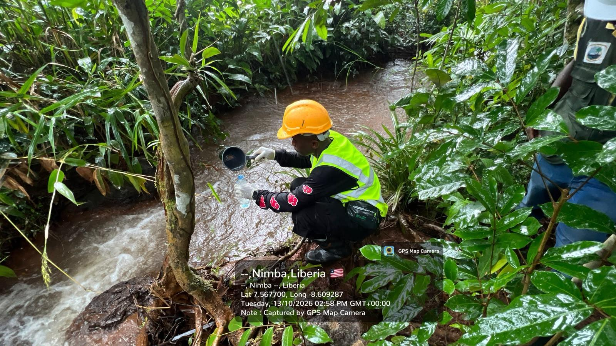  Plate 1: W-SW-VA-001 – Wehyee Downstream (7.5677, -8.6093; 2:58 PM). Reddish-brown, turbid flow. | 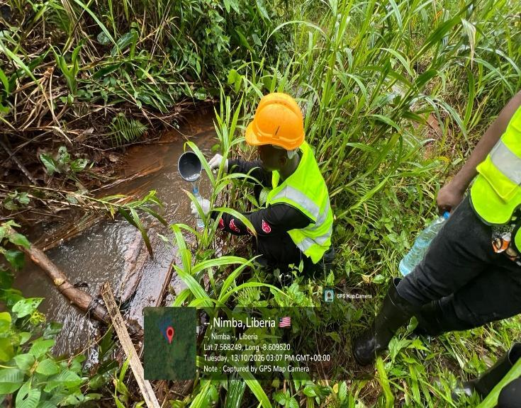  Plate 2: POM-SW-VA-002 – Pompleh Mid-point (7.5682, -8.6095; 3:07 PM). Sampling under dense ground cover.
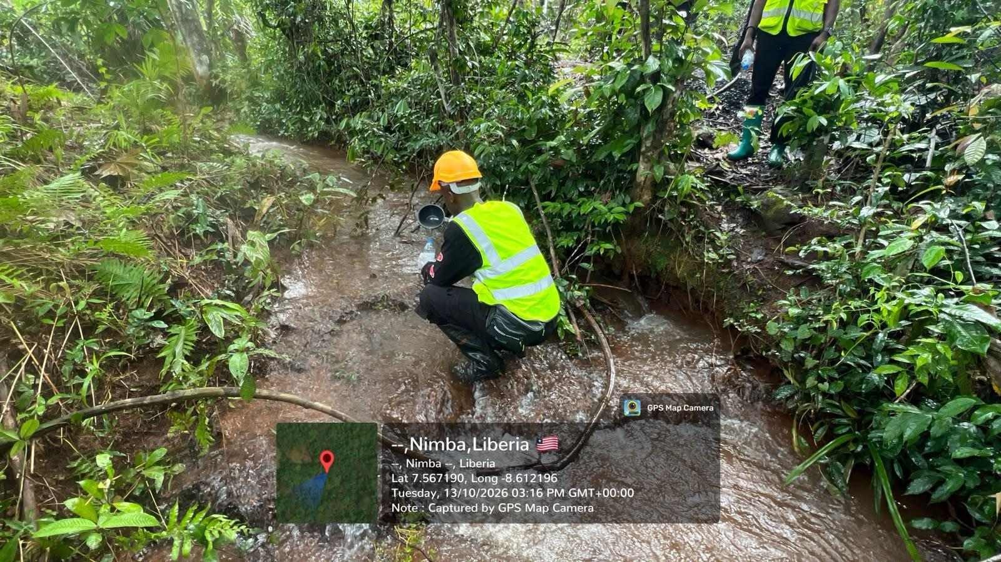  Plate 3: W-SW-VA-002 – Wehyee Mid-point (7.5672, -8.6122; 3:16 PM). Suspended sediment in channel. | 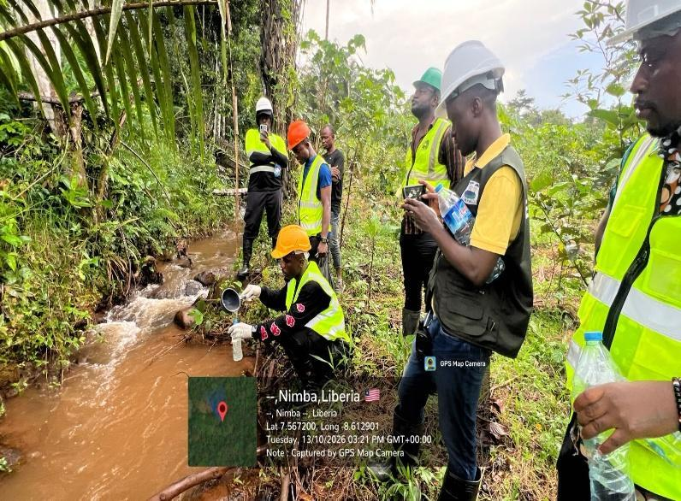  Plate 4: W-SW-VA-003 – Wehyee Upstream (7.5672, -8.6129; 3:21 PM). Uneven banks with exposed soil.

Plates 5–8: JC group sampling along the Wenee, Saymenee, Alphonso farm and Neneyee sampling points, Bolo Town, Nimba County, October 13, 2026.
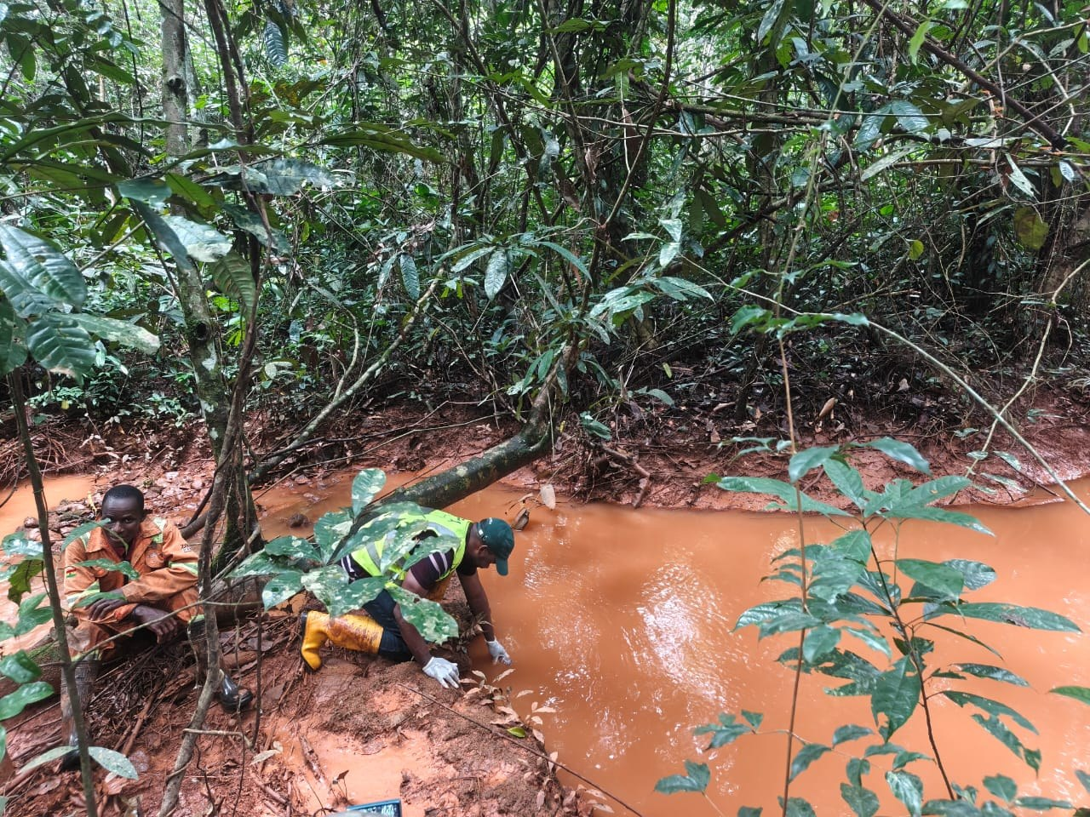  Plate 5: JC group collecting a surface water sample from a reddish-brown, sediment-laden stream channel; iron-rich sediment blankets the bed and banks. | 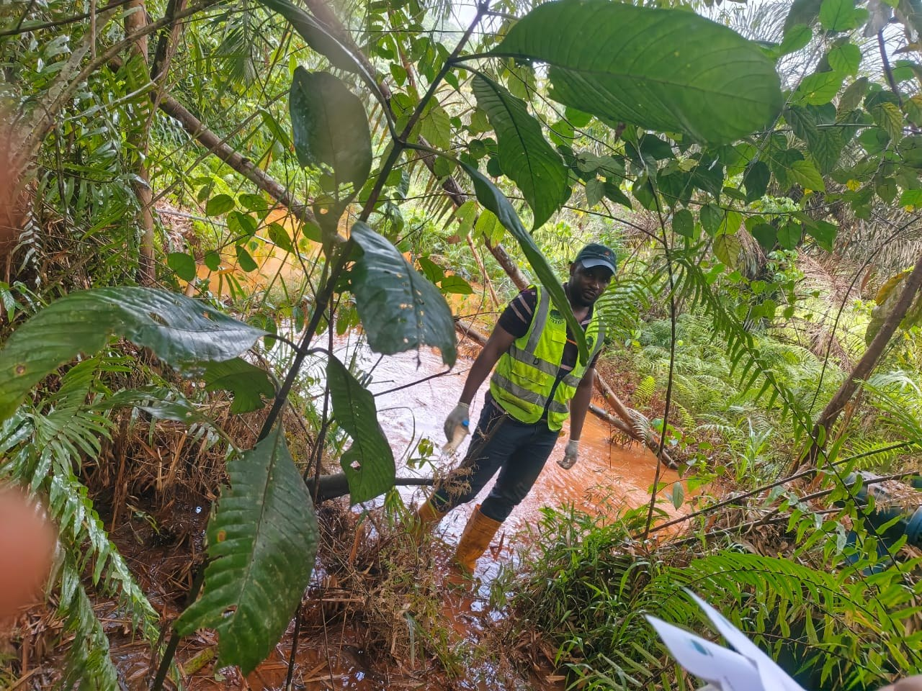  Plate 6: EPA inspector wading the turbid channel at a JC sampling point; dense riparian vegetation with sediment-coated understorey.
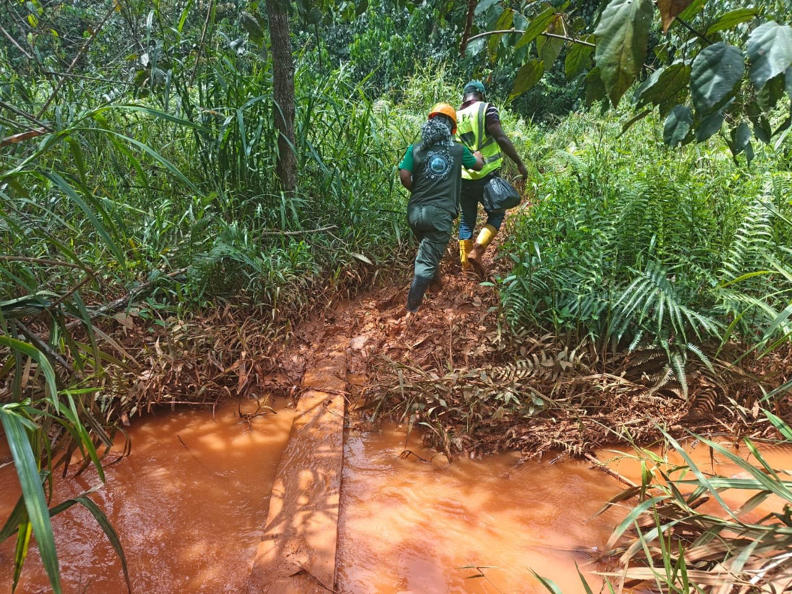  Plate 7: Reddish-brown, visibly turbid flow in a JC group stream, with sediment deposition along the channel margins. | 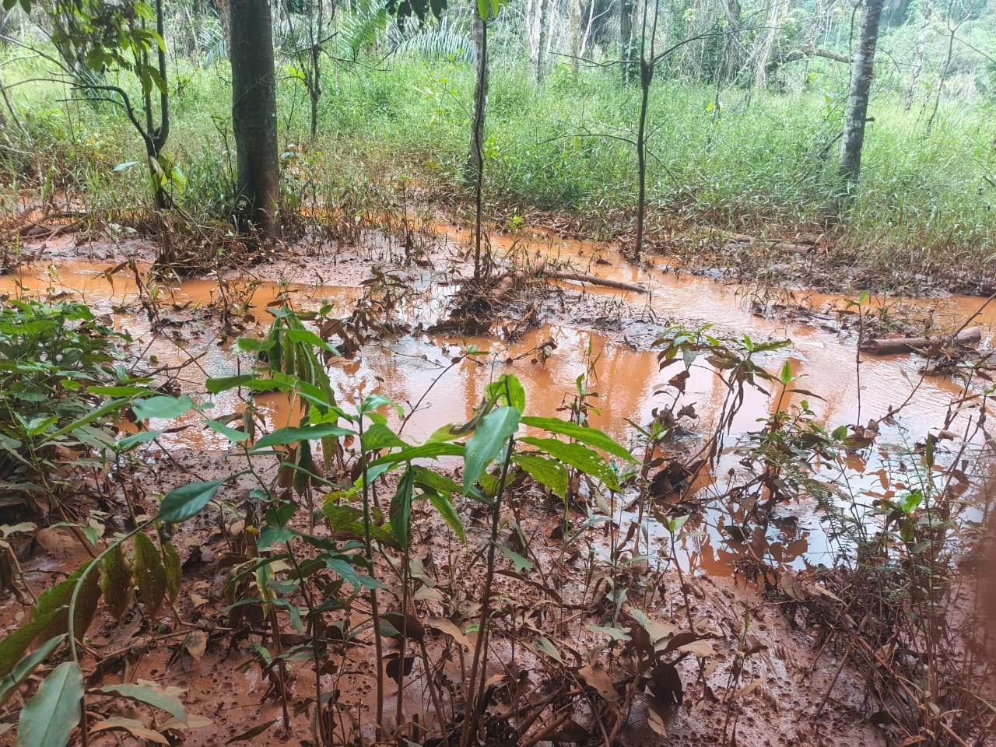  Plate 8: Low-lying land inundated by sediment-laden water, with mine-derived sediment deposited over the ground surface and vegetation.

[To be added: Photographs from the ES group and from the community consultation; confirmation by the JC group of the sampling point shown in each of Plates 5–8.]

APPENDIX B: SOURCE DOCUMENTS
- Bolo Town Investigation Drafted Report V2 – Comprehensive Investigation Report on Water Pollution from ArcelorMittal Mining Operations at Bolo Town (preliminary investigation, August 13, 2026) – used as the structural template for this report.
- Social Team Draft Report – AML Assessment (October 13, 2026).
- ES Group – Physical Observations at Following Sampling Points (Yeewa, Yeewa Korweny 1 & 2).
- Team Varney Armah – Pompleh & Wehyee field notes and photographs.
- Bolo Town Sample Information (Joint) – sample register and TSS results.

